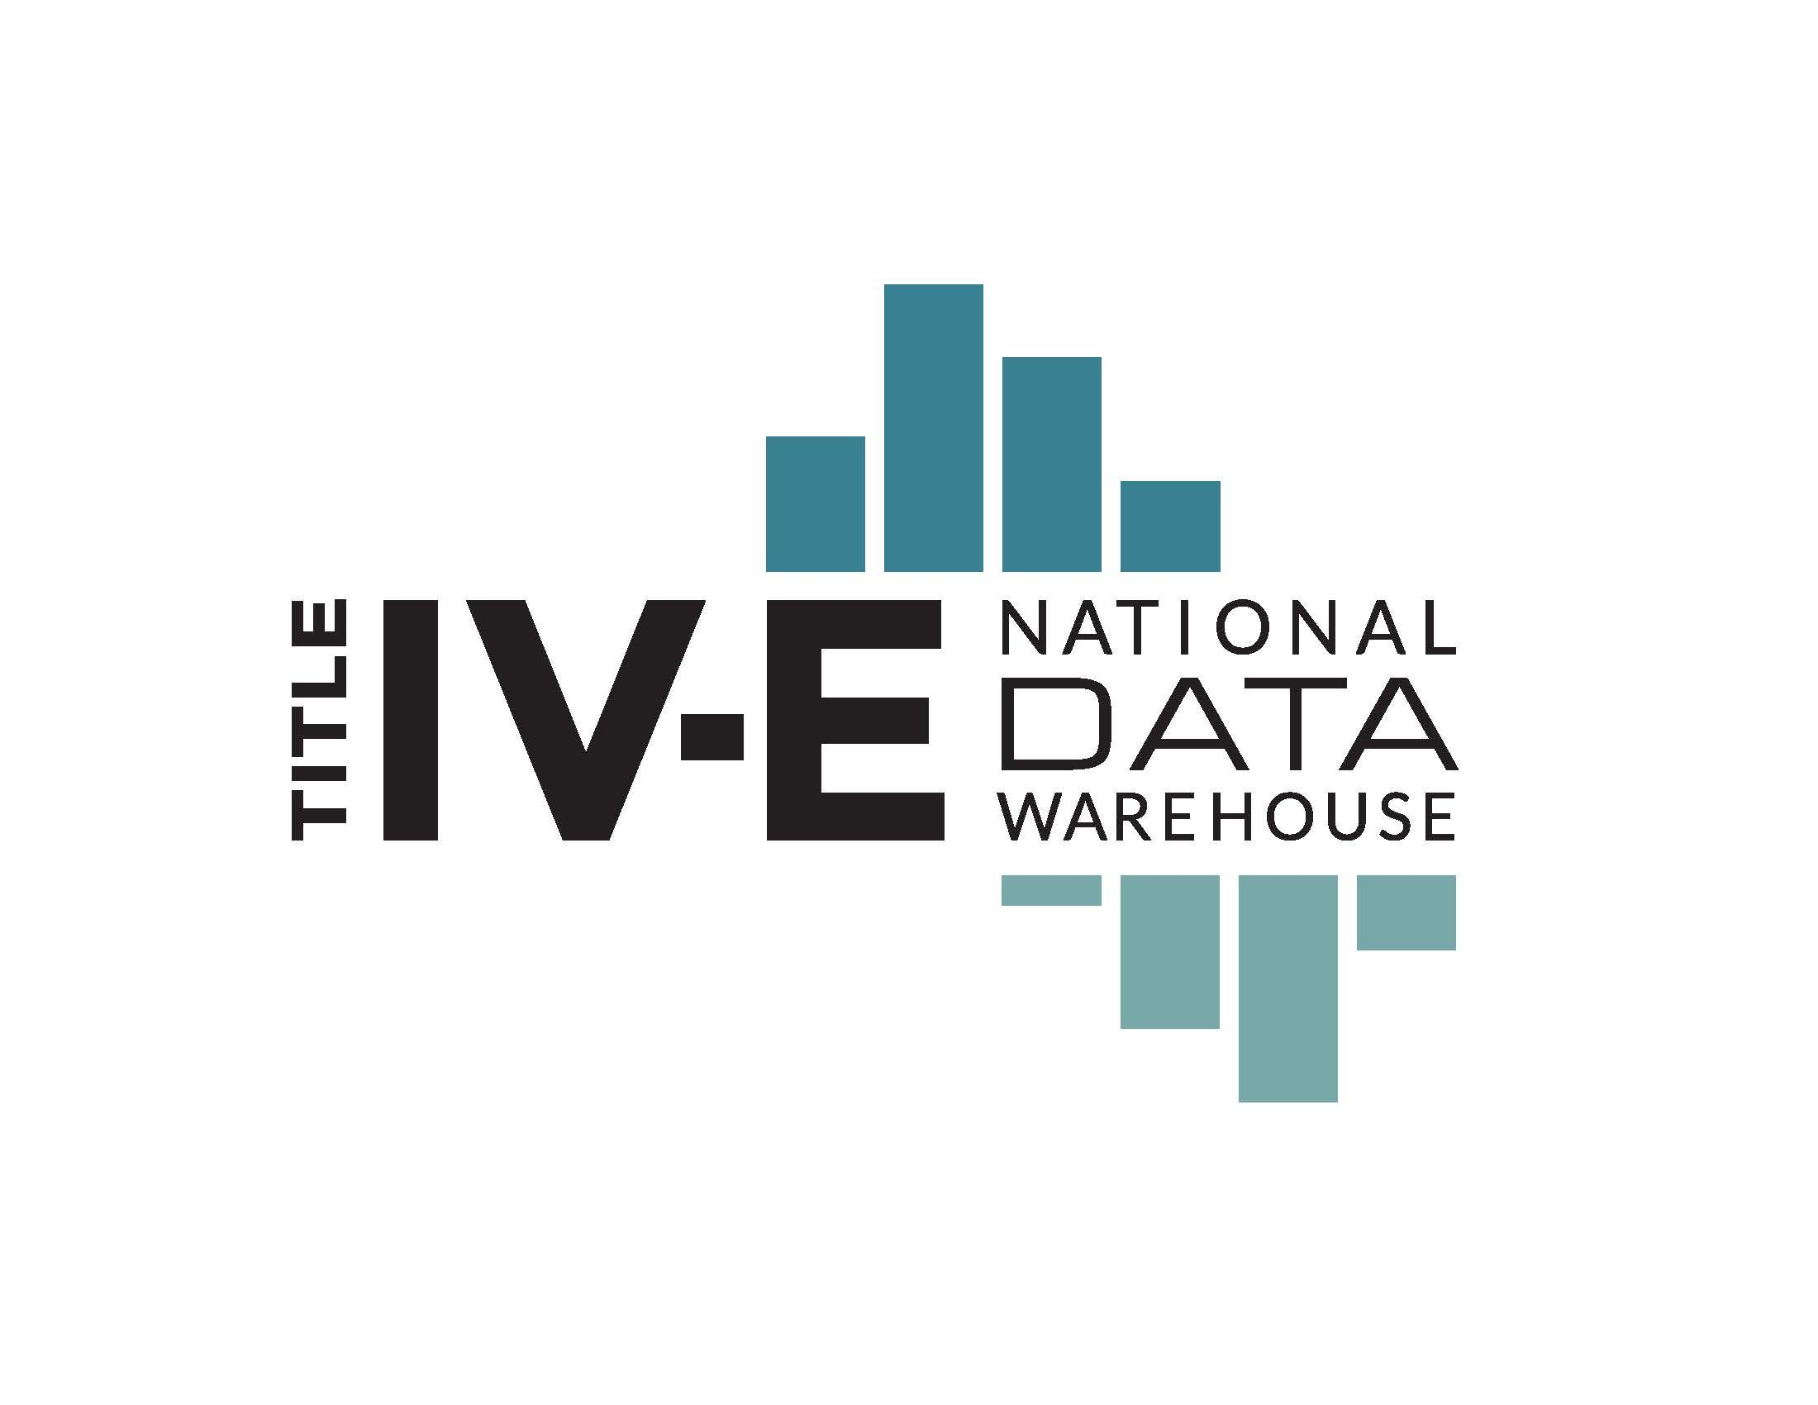
DATA USE AGREEMENT

Effective [Date]

THIS NOTICE DESCRIBES HOW PRIVATE INFORMATION ABOUT STUDENTS AND ALUMNI MAY BE USED AND DISCLOSED. PLEASE REVIEW IT CAREFULLY.

Background
Representatives from numerous federally-funded Title IV-E child welfare educational partnerships across the country have initiated the creation of a national Title IV-E Data Warehouse. The Title IV-E Data Warehouse (hereafter, Data Warehouse) joins data from child welfare educational partnerships across the United States to provide a comprehensive national picture of characteristics of Title IV-E stipend recipients, their associated employment obligations, and (when possible) descriptions of the long-term work of these Title IV-E recipients. The Center for Advanced Studies in Child Welfare (CASCW) at the University of Minnesota acts the Data Host for the Data Warehouse and convenes meetings of the Title IV-E Educational Data Group (hereafter, Data Group). The Data Group - a 4-person panel comprised of contributing members of the Data Warehouse, plus a designee of the Data Host - serves as the governing body for independent research carried out via data requests submitted to the Data Warehouse.
In order to secure data that resides with [name of organization], and in order to ensure the integrity, security, and confidentiality of information maintained by this entity, and to permit appropriate disclosure and use of such data as permitted by law, [name of organization] and

University of Minnesota, Center for Advanced Studies in Child Welfare
Name of organization or person(s)

enter into this agreement to comply with the following specific paragraphs.
1. This agreement is by and between [name of organization], hereinafter termed the “Data Source” and

University of Minnesota, Center for Advanced Studies in Child Welfare via the University of Minnesota Regents
“Data Host”

hereinafter termed the "Data Host."
2. This agreement addresses the conditions under which the Data Source will disclose and the Data Host will obtain and use specific data file(s) specified in section 6. This agreement supersedes any and all agreements between the parties with respect to the use of data from the files specified in section 6. Further, the terms of this agreement can be changed only by a written modification to this agreement or by the parties adopting a new agreement. The parties agree further that instructions or interpretations issued to the Data Host concerning this agreement or the data specified herein, shall not be valid unless issued in writing by the Data Source point-of-contact specified in section 5.
3. The parties mutually agree that the Data Source retains all ownership rights to the data file(s) referred to in this agreement, and that the Data Host does not obtain any right, title, or interest in any of the data furnished by the Data Source. 4. The parties mutually agree that the following named individual is designated as Custodian of the file(s) on behalf of the Data Host and the person will be responsible for the observance of all conditions of use and for establishment and maintenance of security arrangements as specified in this agreement to prevent unauthorized use. The Data Host agrees to notify the Data Source within fifteen (15) days of any change of custodianship.

Traci L. LaLiberte, Executive Director
(Name of Custodian)
University of Minnesota, Center for Advanced Studies in Child Welfare
(Company/Organization)
205 Peters Hall, 1404 Gortner Ave.
(Street Address)
St. Paul, MN 55108
(City/State/ZIP Code)
612-624-2279
(Phone No. - Including Area Code and E-Mail Address, If Applicable)

5. The parties mutually agree that the following named individual will be designated as point-of-contact for the agreement on behalf of the Data Source

(Name of Contact)
(Title/Component)
(Street Address)
(Mail Stop)
(City/State/ZIP Code)
(Phone No. - Including Area Code and E-Mail Address, If Applicable)
6. The Data Host represents, and in furnishing the below listed annual data file(s) relies upon such representation, that such data file(s) will be used solely for the following purpose(s).

Data file(s) | Purpose
Annual stipend recipient enrollment, graduation, and employment files | Provision of aggregate information on the publicly accessible website; generation of partnership-specific reporting (accessible only to said partnership); independent research as approved by the Research Committee
The Data Host represents further that the facts and statements made on the publicly accessible website and for partnership-specific reporting are complete and accurate. Further, the Data Host represents that any study or research protocol or project plan submitted to the Data Source for the purpose of independent research, will be reviewed and approved by the Data Group prior to providing access to pertinent data files. The decisions of the Data Group represent the total use(s) to which the data file(s) specified in section 6 for independent research will be put. The Data Host represents further that, except as specified in an Attachment to this agreement or except as the Data Source shall authorize in writing, the Data Host shall not disclose, release, reveal, show, sell, rent, lease, loan, or otherwise grant access to the data covered by this agreement to any person. The Data Host agrees that, within the Data Host organization, access to the data covered by this agreement shall be limited to the minimum number of individuals necessary to achieve the purpose stated in this section and to those individuals on a need-to-know basis only. The Data Host also acknowledges that it is fully bound by the provisions of Minnesota state law and statutes regarding data privacy now and in the future.
7. The above data file(s) referenced in section 6 is/are covered under this agreement for five years:
MM/YYYY | through | MM/YYYY
8. The parties mutually agree that the aforesaid file(s) (and/or any derivative file(s) [includes any file that maintains individuals]) may be retained by the Data Host until [date], hereinafter known as the "expiration date.” The Data Host agrees to notify the Data Source within 30 days of the expiration date to renew or terminate the agreement. Upon such notice or expiration date, whichever occurs sooner, the Data Source will notify the Data Host either to retain all data files for ongoing use or to destroy such data.
Either party may terminate the agreement at any time for any reason immediately upon written notice. Upon such notice, the Data Source will cease releasing data to the Data Host under this agreement. In the advent of termination of participation, the Data Source may request that the Data Host cease use of and destroy any data utilized for aggregate information provided via the publicly accessible website. However, data utilized for independent research may be retained in accordance with data retention guidelines of associated publishers and/or sponsors of said research. Sections 3, 6, 8, 11, 12, 13, 15, 16 and 17 shall survive termination of this agreement.
9. The Data Host agrees to establish appropriate administrative, technical, and physical safeguards to protect the confidentiality of the data and to prevent unauthorized use or access to it. The Data Source and Data Host acknowledge the use of unsecured telecommunications, the Internet, to transmit individually unidentifiable or deducible information derived from the file(s) specified in section 6. Further, the Data Host agrees that the data must not be physically moved or transmitted in any way from the site indicated in item number 4 without written approval from the Data Source.
10. The Data Host agrees that the authorized representatives of the Data Source will be granted access on request to premises where the aforesaid file(s) are kept for the purpose of inspecting security arrangements confirming whether the Data Host is in compliance with the security requirements specified in paragraph 9.
11. The Data Host agrees that no findings, listing, or information derived from the file(s) specified in section 6 with or without identifiers, may be released if such findings, listing, or information contain any combination of data elements that might allow the deduction of a beneficiary's identification without first obtaining written authorization from the Research Committee. Examples of such data elements include but are not limited to geographic indicator, age, or sex.
12. The Data Host agrees to publicly release aggregate, de-identified data. Publicly available aggregate reporting functions of the website will not identify individual students. Partnership-specific reporting structures will be made available to the Data Source via secure log-in.
13. The Data Host understands and agrees that they may not reuse original or derivative data file(s) unless initiating independent research and having obtained prior written approval from the Research Committee.
14. The parties mutually agree that the following specified Attachments are part of this agreement:

Attachment A: Title IV-E Educational Data Group Governing Structure
15. On behalf of the Data Host the undersigned individual hereby attests that he or she is authorized to enter into this agreement and agrees to all the terms specified herein.

(Name and Title of Individual - Typed or Printed)
Office of Sponsored Projects Administration
(Company/Organization)
450 McNamara Center, 200 Oak Street SE
(Street Address)
Minneapolis, MN 55455-2070
(City/State/ZIP Code)
612-624-5599
(Phone No. - Including Area Code and E-Mail Address, If Applicable)
(Signature) | (Date)
16. The Custodian, as named in paragraph 4, hereby acknowledges his/her appointment as Custodian of the aforesaid file(s) on behalf of the Data Host, and agrees to comply with all of the provisions of this agreement on behalf of the Data Host.

Traci L. LaLiberte, Executive Director
(Typed or Printed Name and Title of Custodian of File(s)
(Signature) | (Date)

17. On behalf of the Data Source the undersigned individual hereby attests that he or she is authorized to enter into this agreement and agrees to all the terms specified herein.

(Typed or Printed Name and Title of the Data Source Representative)
(Signature) | (Date)

Attachment A: Title IV-E Educational Data Group Governing Structure

The National Title IV-E Child Welfare Research Committee will form a subgroup, the Title IV-E Educational Data Group. The Title IV-E Educational Data Group shall be composed of five members, four members from the Title IV-E Child Welfare Research Committee and one member representing the Data Host. The initial group shall be comprised of four volunteer members of the Research Committee who were the originators of the National Title IV-E Data Taskforce (the precipitant to the Research Committee) and one Data Host-appointed member. No two members of the Data Group shall represent the same Title IV-E Education program or state at the same time.

Educational Data Group members from the Title IV-E Child Welfare Research Committee shall serve two-year terms (with two members initially serving a four-year term). Two members will rotate out of the Educational Data Group every two years. New members will be elected by Research Committee members at the Child Welfare Track Meeting of the Council on Social Work Education Annual Program Meeting.

Proposals and requests for data shall be subject to review criteria set by the Educational Data Group. Review criteria include, but are not limited to: the scope of proposed research (e.g., partnerships/states, variables sought, time period, etc.), connection of the research to the stated purpose of Title IV-E funding, and feasibility of research given the available data. Direct comparisons among individual programs will not be permissible in data requests. The Educational Data Group shall send notification of approval (or lack thereof) for the research proposal within four weeks of receipt.

